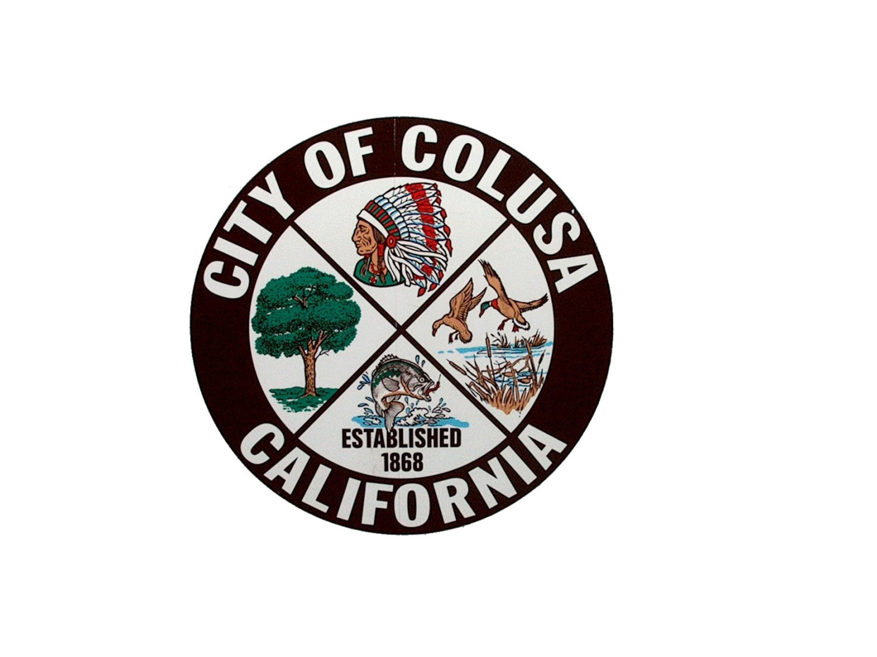
NOTICE OF PUBLIC HEARING

CITY OF COLUSA

PLANNING DIRECTOR

NOTICE IS HEREBY GIVEN THAT THE PLANNING DIRECTOR will hold a Public Hearing in the City Council chambers in the Colusa City Hall located at 425 Webster Street on Tuesday July 15, at 11:00 a.m. or soon thereafter. The meeting is for the purpose of reviewing the following item:
Applicant: Colusa Industrial Properties (Colusa Meat)
Owners: Colusa Industrial Properties
Location: 7295 Industrial Way, Colusa, CA 95932
APN: 017-030-115
Zoning: M-2 – General Industrial with a C-3 Secondary Traffic Pattern Zone Airport Land Use Compatibility Zone Overlay
Project: Minor Use Permit for a Livestock animal slaughter and processing facility

The Planning Director will consider an application for a Minor Use Permit for a livestock (cattle, swine, sheep and goats) on a 1-acre of a 10.92-acre parcel that contains an existing 3,600 square foot structure. The site will be improved with outdoor storage pens with access to water, food and shade. Parking area will also be installed.

Environmental Review: CEQA Exempt Pursuant to 15152 – Tiering and 15162 – Subsequent EIR or Negative Declaration
City Contact: Jake Morley Planning Department, or Jesse Cain City Manager,
Phone: (530) 458-4941

All interested parties are invited to attend and express their opinions or provide written comments before the hearing. Written comments can be submitted to the Planning Department at the above address, until 5:00 p.m. on Monday, July 14, 2025. Oral comments can be made at the Public Hearing.
Subsequent to the Planning Director hearing, an appeal period of ten (10) calendar days will commence, during which an appeal of the Planning Director’s decision may be made to the Colusa City Council. Appeals must be accompanied by a corresponding fee and may be filed at the Planning Department in City Hall at the address above. Challenges to the Planning Director’s decision may be limited only to those issues raised at the public hearing described in this notice or in written correspondence delivered to the City of Colusa at, or prior to, the public hearing.

