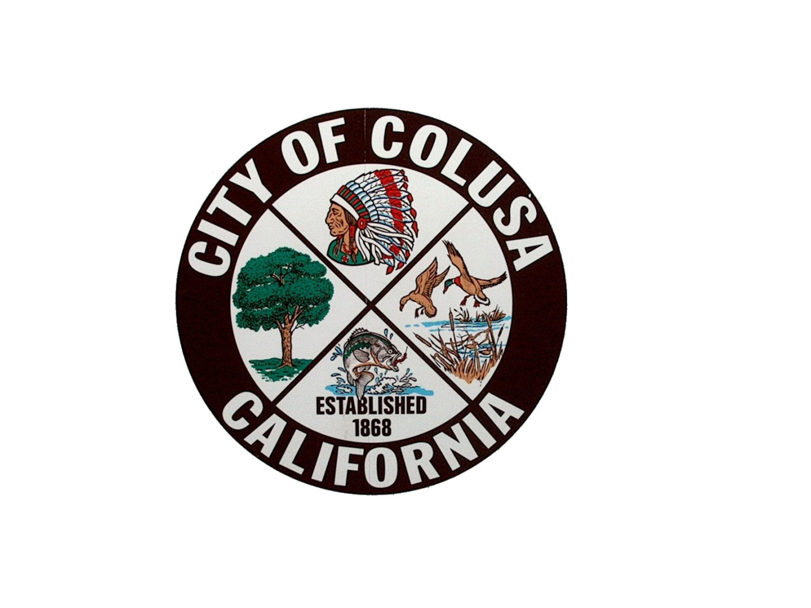
NOTICE OF PUBLIC HEARING

CITY OF COLUSA PLANNING COMMISSION

NOTICE IS HEREBY GIVEN THAT THE PLANNING COMMISSION will hold a Public Hearing in the City Council chambers in the Colusa City Hall located at 425 Webster Street on Wednesday, June 26th, at 7:00 p.m. or soon thereafter. The meeting is for the purpose of reviewing the following item:
Applicant: Colusa Industrial Properties
Owners: Colusa Industrial Properties and Wescott Ranch LLC
Location: Wescott Road, City of Colusa
APN: 017-030-050 and 107
Zoning: SFR – Single Family Residential
Project: Tentative Parcel Map – 170 single family lots, 53 duplex lots, 1 commercial lot, a neighborhood park, and 1 high density lot.

The Planning Commission will consider an application for a Development Agreement, General Plan Amendment, Rezone and Tentative Subdivision map submitted to subdivide approximately 90.95 acres consisting of two parcels (1 parcel = 88.97 ac, 1 parcel = 1.98 ac) into as the following:
170 single family lots – 46.54 Ac
53 duplex lots – 16.27 Ac
1 commercial lot – 1.17 Ac
1 neighborhood park lot – 3.51 Ac
1 high density lot - 7.45 Ac
1 open space lot – 14.03 Ac

This current proposal contemplates installation of city infrastructure improvements along with electric, telephone and cable throughout the project, and includes roadway frontage improvement along Wescott Road and full roadway improvements throughout the project. The Planning commission will make a recommendation to the City Council to adopt an initial study and mitigated negative declaration, conditions of approval for this project.
Environmental Review: Initial Study and Mitigated Negative Declaration
City Contact: David Swartz, City Engineer/Planning Department, or Jesse Cain, City Manager, Mark Tomey, Planning Department
Phone: (530) 682-9832 or 530-682-2933 or 530-458-4941

All interested parties are invited to attend and express their opinions or provide written comments before the hearing. Written comments can be submitted to the Planning Department at the above address, until 5:00 p.m. on Wednesday, June 26th, 2024. Oral comments can be made at the Public Hearing. Copies of the Initial Study and Mitigated Negative Declaration can be found on the Cities web site, and at City Hall.
Subsequent to the Planning Commission hearing, an appeal period of ten (10) calendar days will commence, during which an appeal of the Planning Commission’s decision may be made to the Colusa City Council. Appeals must be accompanied by a corresponding fee and may be filed at the Planning Department in City Hall at the address above. Challenges to Planning Commission’s decision may be limited only to those issues raised at the public hearing described in this notice or in written correspondence delivered to the City of Colusa at, or prior to, the public hearing.

