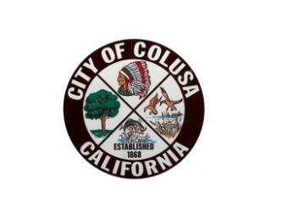

**NOTICE OF PUBLIC HEARING**

# CITY OF COLUSA

NOTICE IS HEREBY GIVEN THAT THE CITY OF COLUSA CITY COUNCIL will hold a Public Hearing in the City Council chambers in the Colusa City Hall located at 425 Webster Street on Tuesday, January 7th, 2025, at 6:00 p.m. or soon thereafter.  The meeting is to review the following items:

Community Development Block Grant (CDBG)—Micro-Enterprise Loan Program grant, Closeout for award in the amount of $250,000. A report will be given on total fund expenditures and use of funds covered by the program.

All interested parties are invited to attend and express their opinions or provide written comments before the hearing.  Documents may be reviewed at, and written comments can be submitted to, the Finance Department at the above address, until 5:00 p.m. on Tuesday, January 7, 2025.  Oral comments can be made at the public hearing.  Additional questions may be directed to Ishrat Aziz-Khan, Finance Director, at (530) 458-4941 or by email at fdirector@cityofcolusa.gov.